Marketing Guide

## Background:

* Background information about the industry or the problem
* Problem Statement: what is the problem your product is solving?
* Product Goals: how does your product solve the problem

Based on the recent study , the food delivery/hospitality industry is incurring huge operational cost and the on-time delivery of the food is also a on-going concern . To address the problem ,there is a need for automating the process entire supply chain of food delivery right from ordering the food to the last mile delivery, thereby food delivery/hospitality industry shall achieve significant reduction in the cost and also increase the productivity , thus improving the bottom line improving the topline.

According to the survey or data available, we surmise that 60% of the US population order food online(<https://upserve.com/restaurant-insider/online-ordering-statistics/>) and there is an immense potential in tapping this market and DoorDash as a solution is deemed fit to help our customers with their operational needs and cutting down on the operational cost. The market size for this is $212 Mn with a CAGR of 35% (

[(https://www.prnewswire.com/in/news-releases/autonomous-last-mile-delivery-market-size-is-projected-to-reach-usd-84-72-billion-by-2030-at-cagr-24-4-valuates-reports-802847682.html](https://www.prnewswire.com/in/news-releases/autonomous-last-mile-delivery-market-size-is-projected-to-reach-usd-84-72-billion-by-2030-at-cagr-24-4-valuates-reports-802847682.html)) , which is very lucarative business to capitalize on.

DoorDash being one of the prominent player in the automated food delivery solution provider, shall bespoke the solution to cater to the customer’s requirements be it in terms of distance , re-routing and host of other features the customers intends to have .

To keep ourselves with the everchanging market demands, Doordash shall have the below new features in the product :

* Delivery of the goods right from origin to the last mile delivery without human intervention or minimal human intervention in case of failure.
* Build an efficient mobile or native app for the users to place the order, track the order, notifications of the delivery, secured transaction at the last mile delivery to authenticate the user.
* Remote asset management and tracking

## Market background:

Write a short description of your market and audience:

* Outline your target audience
* Describe your target market
* Describe your competitors

Doordash product is mainly targeted to the food delivery/hospital industries, the end customers being the users in the age group of 18-75, who shall place the food order online. There is a surge in the online food ordering and Doordash is geared up to help our customer to achieve their goals.

Doordash is designed to catered to the needs of the food and hospitality across the globe. However, Doordash shall be supported in US, Some parts of Asia. However, there are plans to increase the footprints across the globe.

There are prominent players in the market who are in direct competition with Doordash. There are around 10 players in the automated food system in the market out of which Nuro, Starship, Eliport are the major competitors to Doordash. Doordash provides flexible business model and also the capabilities/features of Doordash are the key differentiators (with more 5 patents pending for this product on Ai/ML modeling) .

## Product Background and Positioning:

Describe your product and what marketing needs to know about it:

* Describe your product value proposition
* Outline at least three of your main features, describe what these features do
* Add at least one visual element, such as screenshots or mocks to describe your product

Doordash is end-to-end turnkey solution which is specifically catered to the food delivery /hospitality industry. The solution can broadly be split into three parts . First, the **Mobile app** target for the **end user** whichwill be used for ordering food.

Second is the backend which is specifically designed for the operations team/customer support to track the robot, estimated time and the support team for triaging any issues or customer complaints.

The third one is the indigenous Dashdoor robot, responsible for the delivery of the product right from the origin to the destination(The robot is designed with the custom board hardware with all the sensors, GPS modems) and built in AI/ML algorithms to make smart decision on its own. However, there shall be intervention from the operations team to train the robot and to get acquainted with the stuff it needs to do.

The product aims to reduce the operational cost for their customers by 50% and increase the productivity by 30% by completely automating the task carried out by human beings, the human intervention is drastically reduced by nearly by 50%, which shall be a great saving for the organization with one time investment in Doordash product.

Key features:

The Doordash product has the following key features

1. Mobile App(front end) and the backend development : The Mobile app is used to place the food by logging with the credentials, the user can navigate through the app and place the order, the app is intuitive and simple to use without much effort.
2. Doordash re-routing feature: If the user wants to re-route it other location in the midway of the delivery, the user has the option to command the Doordash robot to do from the mobile app.
3. Doordash Realtime tracking: The user can track the order and also the estimated time for delivery.
4. Doordash authentication at the last mile delivery : At the last mile, the user has to authenticate himself by either scanning bar code which is on top of the Doordash robot to authenticate, there can be other means of authentication can be provided at the last mile delivery as the customer’s request.
5. Analytics to make business decision : The built-in analytics engine provides information about the orders placed and shall present the information to the management and stakeholders to make the informed decision and change the strategy for the business, if need be.

Mocks

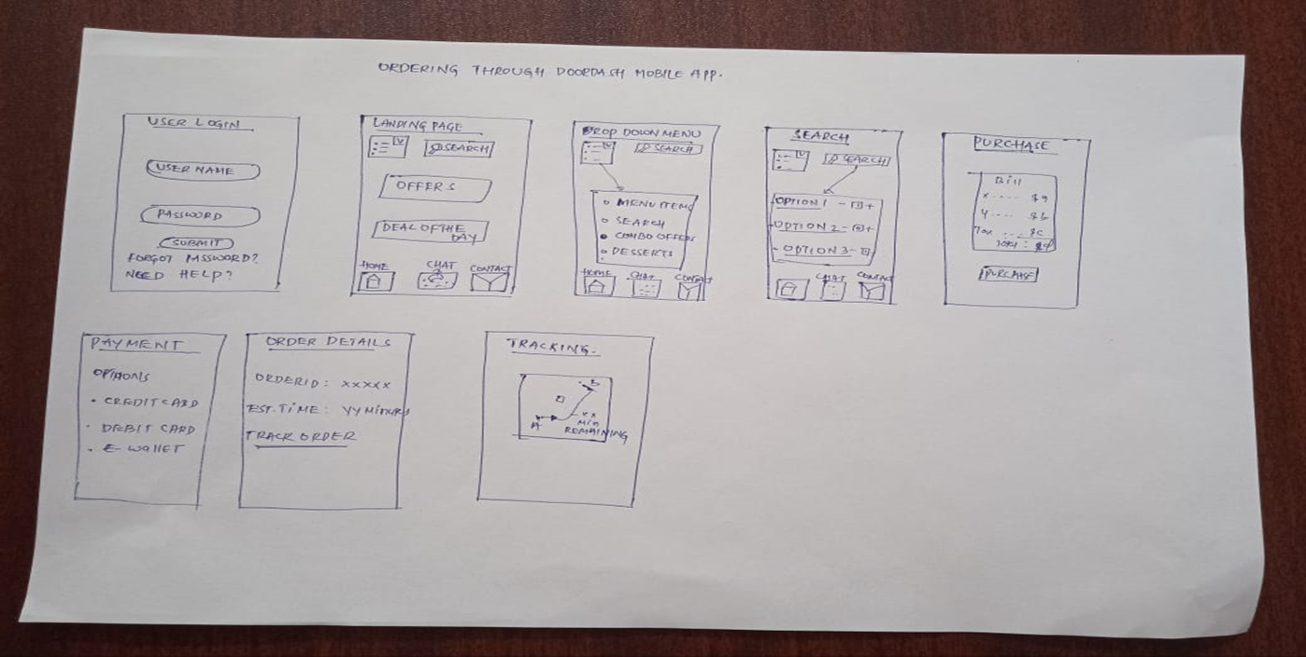

The above figure depicts the flow, wherein the user logs in to the mobile app and places the order, which shall be given to the Doordash robot for further proceedings.

The above figure depicts the call flow, wherein the Doordash robot travels from the origin towards the destination to deliver the app. The notification will be sent to the user and also to the Doordash backend system about the delivery and it is updated in the real time. There is a provision to query the status of the robot, where it is right now and also know the estimated time of delivery.